Data link: <https://catalog.data.gov/dataset/inpatient-prospective-payment-system-ipps-provider-summary-for-the-top-100-diagnosis-relat>

For this project, the data provided was about recorded data about hospital-specific charges. The dataset includes data related to more than 3,000 U.S. hospitals. The hospitals receive Medicare Inpatient Prospective Payment System payments from the government. The aid is receiving for top 100 most frequently billed discharges. The discharges are paid under Medicare scheme depending on rate of every discharge utilizing Medicare Severity Diagnosis Related Group. The data collected is of the year Fiscal Year (FY) 2011.

Medical clinics or the hospitals that provides care figure out what they will charge for such as services and administrations gave to patients and these charges are the sum the clinic bills for care provided. The Total Payment incorporates the MS-DRG sum, charge all out outlay, recipient essential payer guarantee instalment sum, recipient deductible sum etc.

For these DRGs, normal charges, normal absolute payments, and normal Medicare payments are determined at the individual clinic level. Clients will have the option to make correlations between the sum charged by singular emergency clinics with in the local area as well as across the country, for administrations that may be outfitted regarding a specific inpatient admissions and stays.

# Plot 1

The number of patients is depicted in the following bar chart that shows the number of patients records available in the dataset.

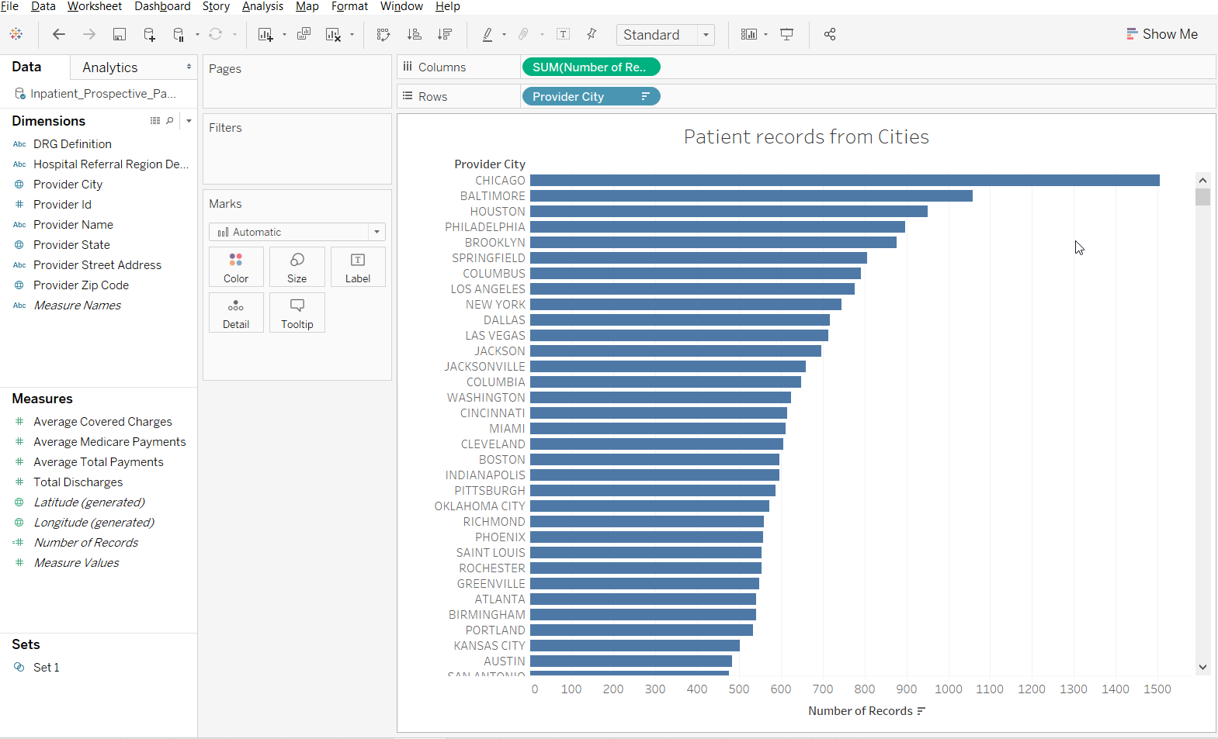

Highest number of patients or records are from Chicago city. Other cities that have the significant number of patients are Baltimore, Houston, Philadelphia,

# Plot2

For the first plot, the patient discharges are plotted for different cities.

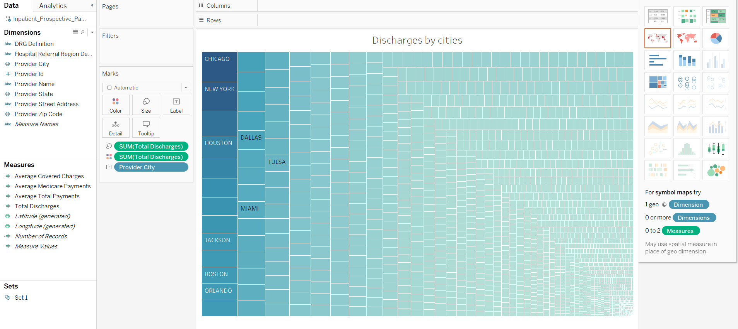

From the above table, the significant number of patient discharges are from Chicago, New York, Boston, Dallas and Miami.

# Plot3

In the next plot the number of discharges is compared by the provider names.

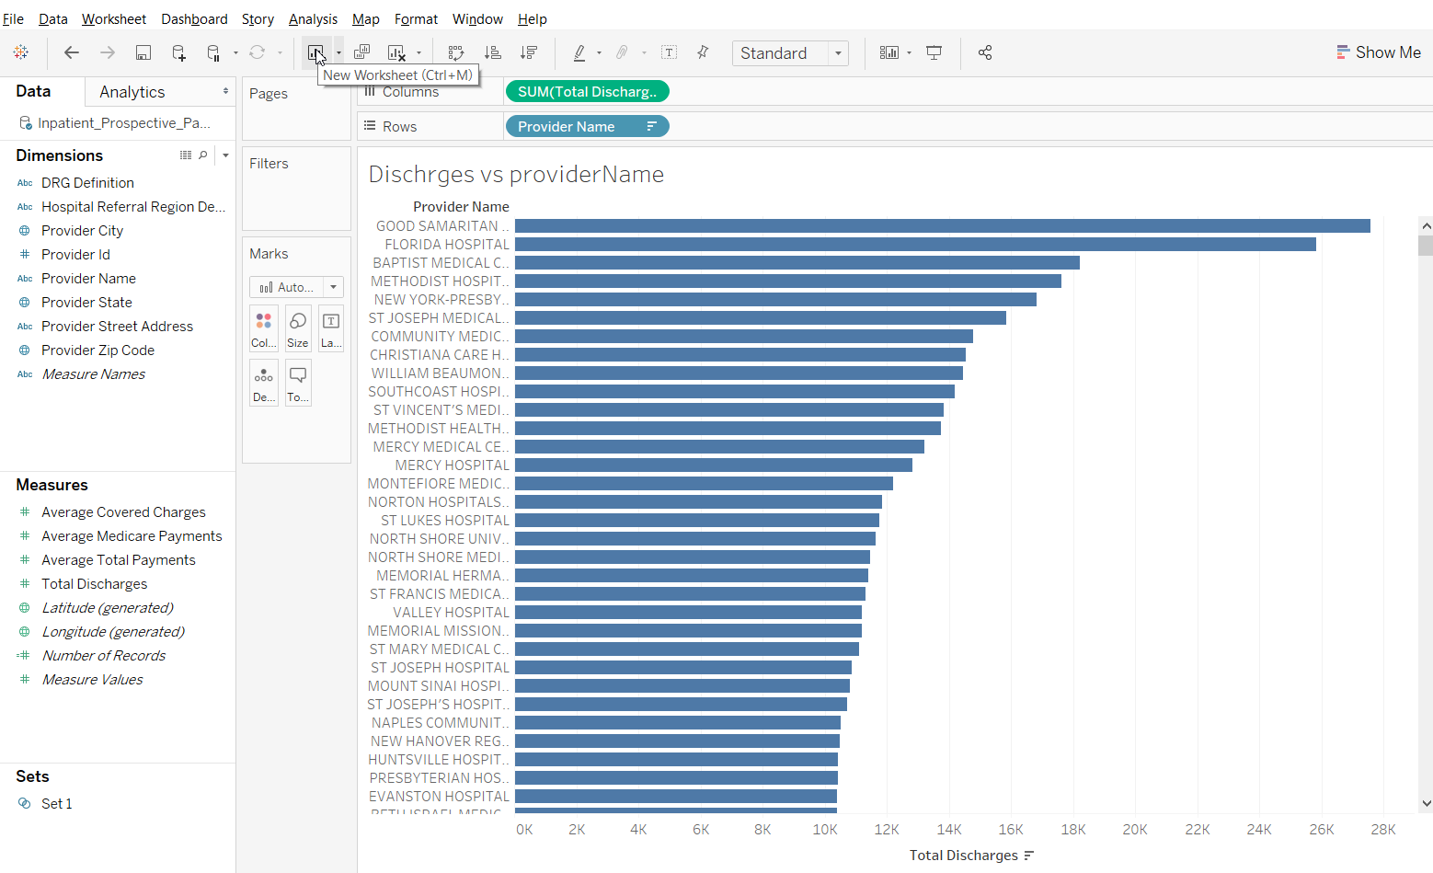

Here, it is clear that the highest number of discharges are released by the Good Samaritan hospital.

# Plot4

The average covered charges are plotted for different providers using the horizontal bar plot.

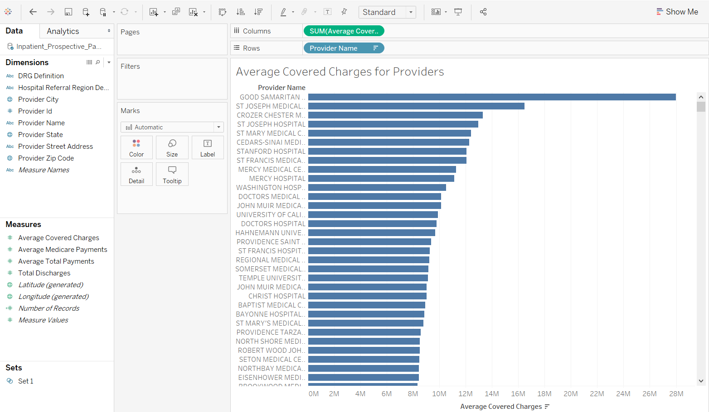 Here too it can be stated that “Good Samaritan hospital” is the top provider in terms of average covered charges for the patients.

# Plot5

The following plot depicts the number of the referrals from different regions.

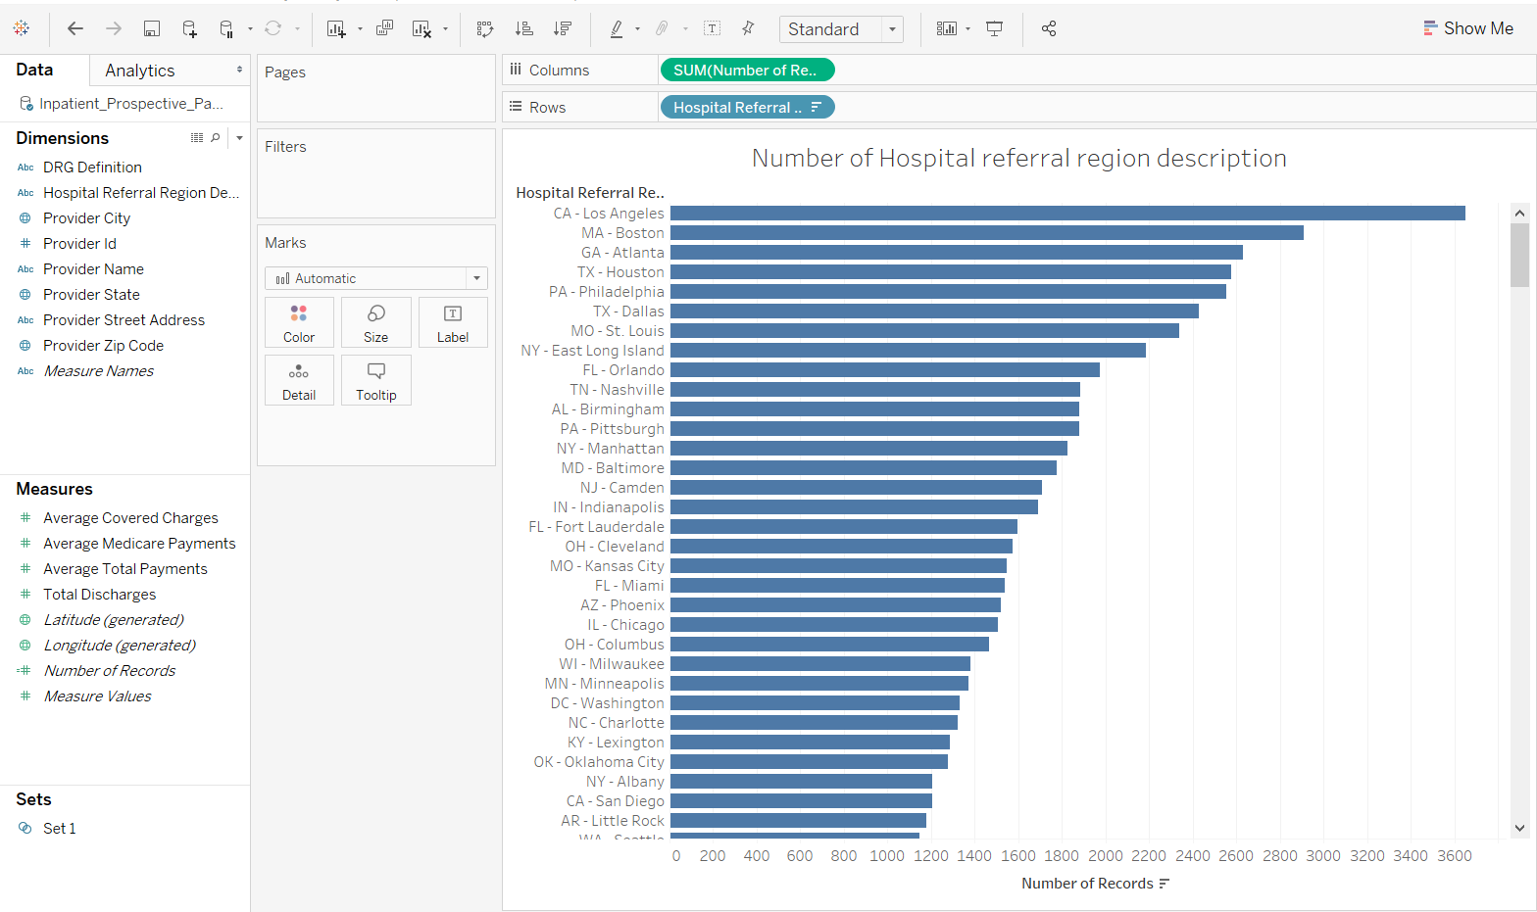

Highest number of referrals are recorded in the CA-Los Angeles category. Other significant categories are, MA-Boston, GA-Atlanta, TX- Huston.

# Plot6

In the following plot, the discharges against the referrals are plots;

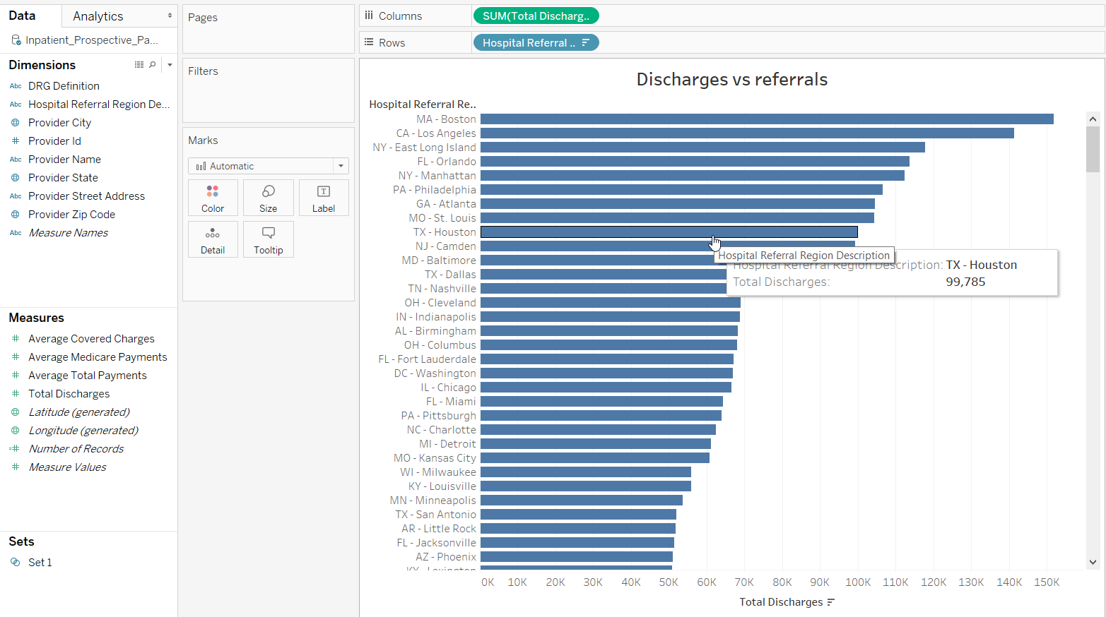

Here, the highest number of discharges are recorded for MA-Boston, CA-Los Angeles, NY-East Long Island.

# Plot7

In order to investigate more thoroughly the following plot is generated.

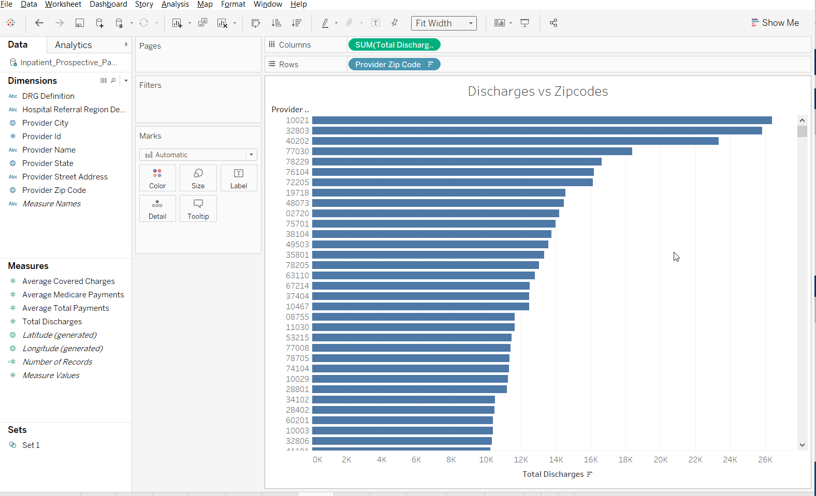

The discharges from the different zip codes are plotted above which shows the zip code 10021, 32803, 40202 are the top zip codes which shows the highest number of discharges from the hospital providers.

# Plot8

In the next plot, the total pay by the providers are calculated and plotted using the tree map.

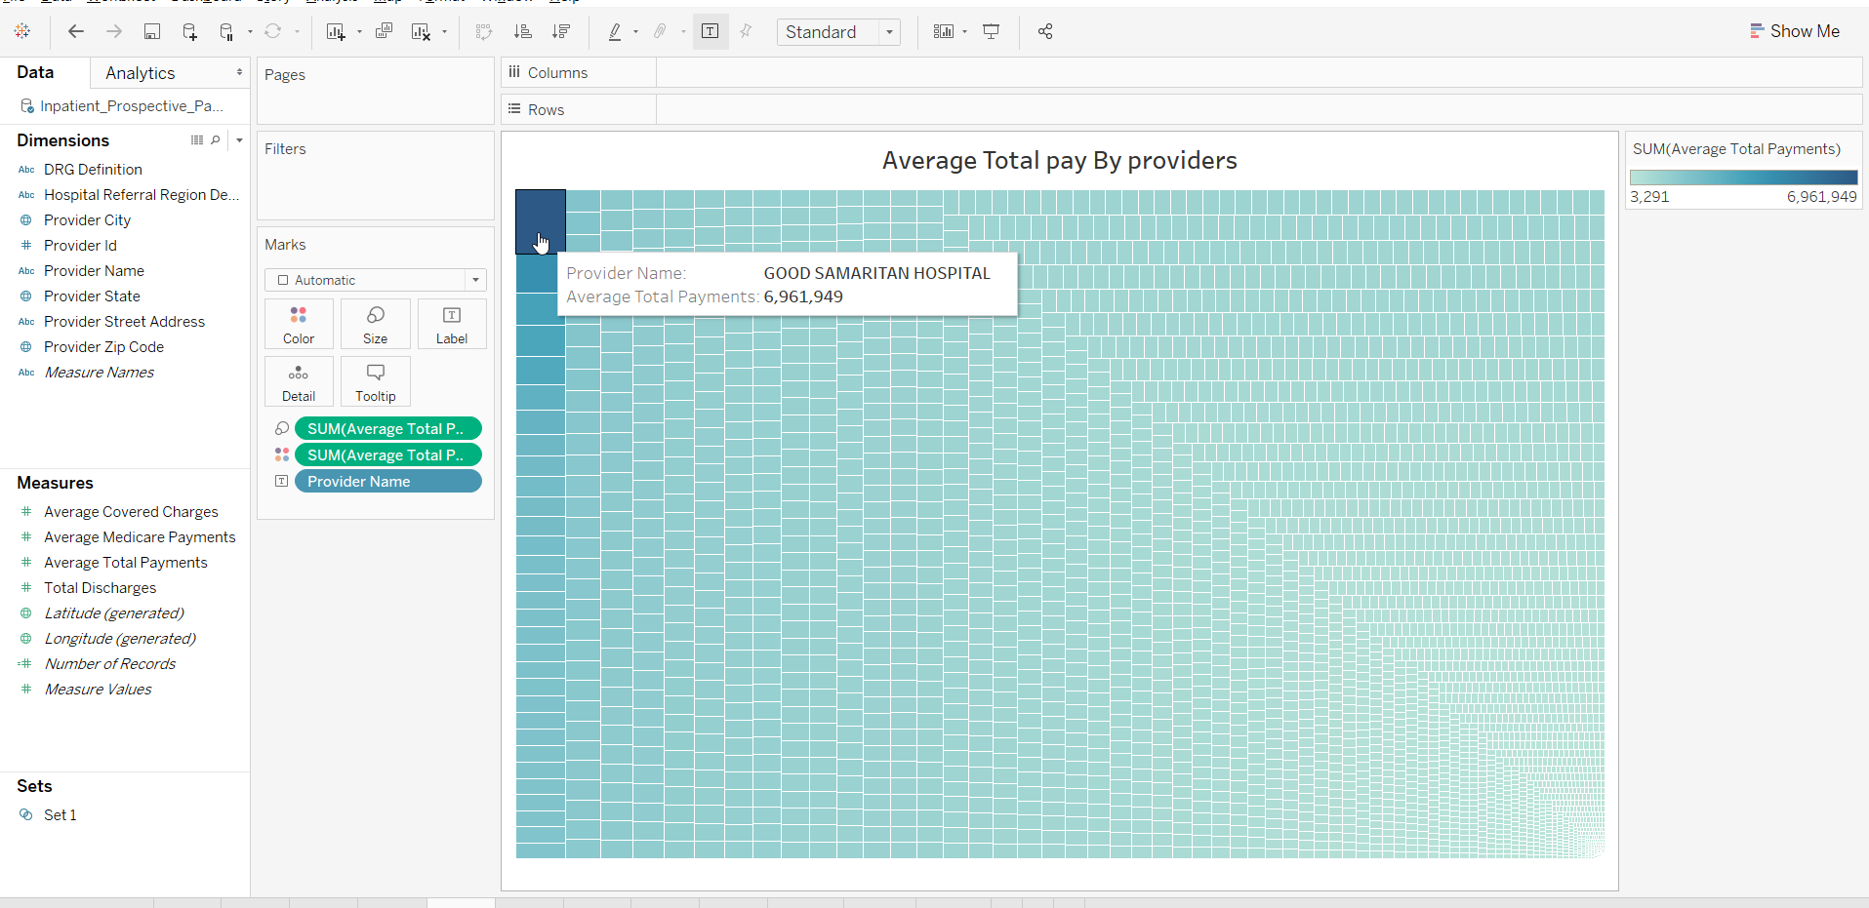

Here too, similar to the Average pay the total pay is highest paid by Good Samaritan Hospital.

# Plot9

In the next plot, the amount of average total pay is calculated for different states.

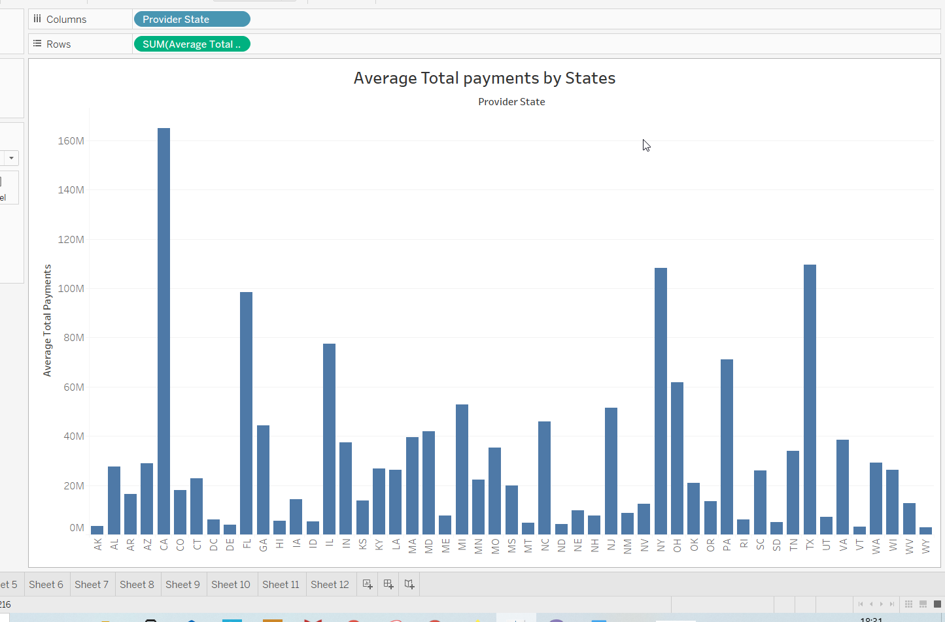

Significant states that are paying highest average payments are, CA, NY, TX, IL, FL.

# Plot10

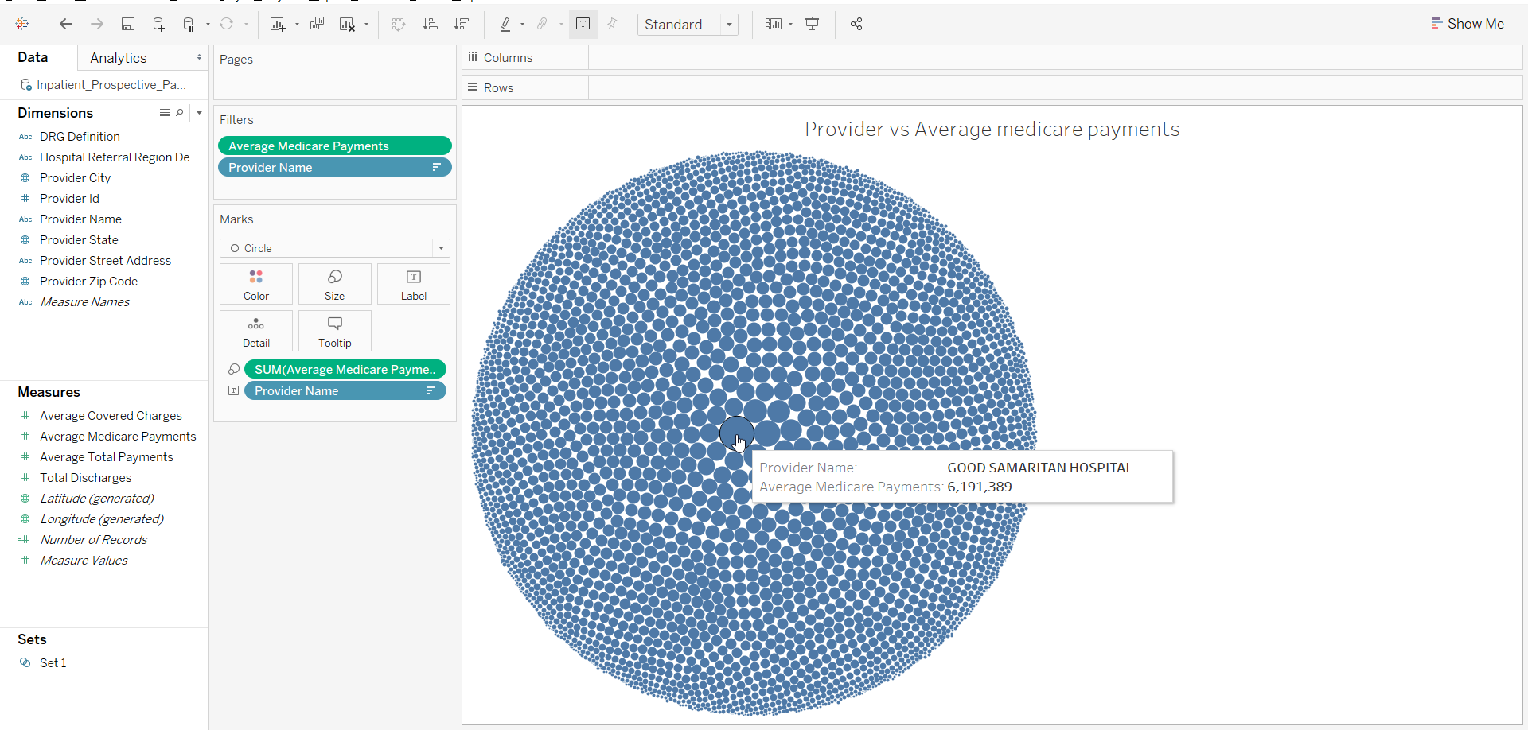

# Plot11

Available average Medicare payments from the different cities are plotted.

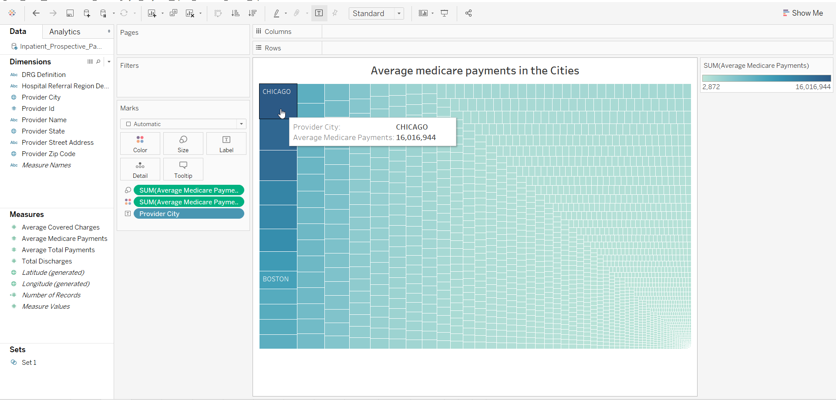

Here, it can be stated that highest amount of average Medicare payment is recorded for Chicago.

# Plot12

In the next bar plot, the number of discharges in the different states are plotted.

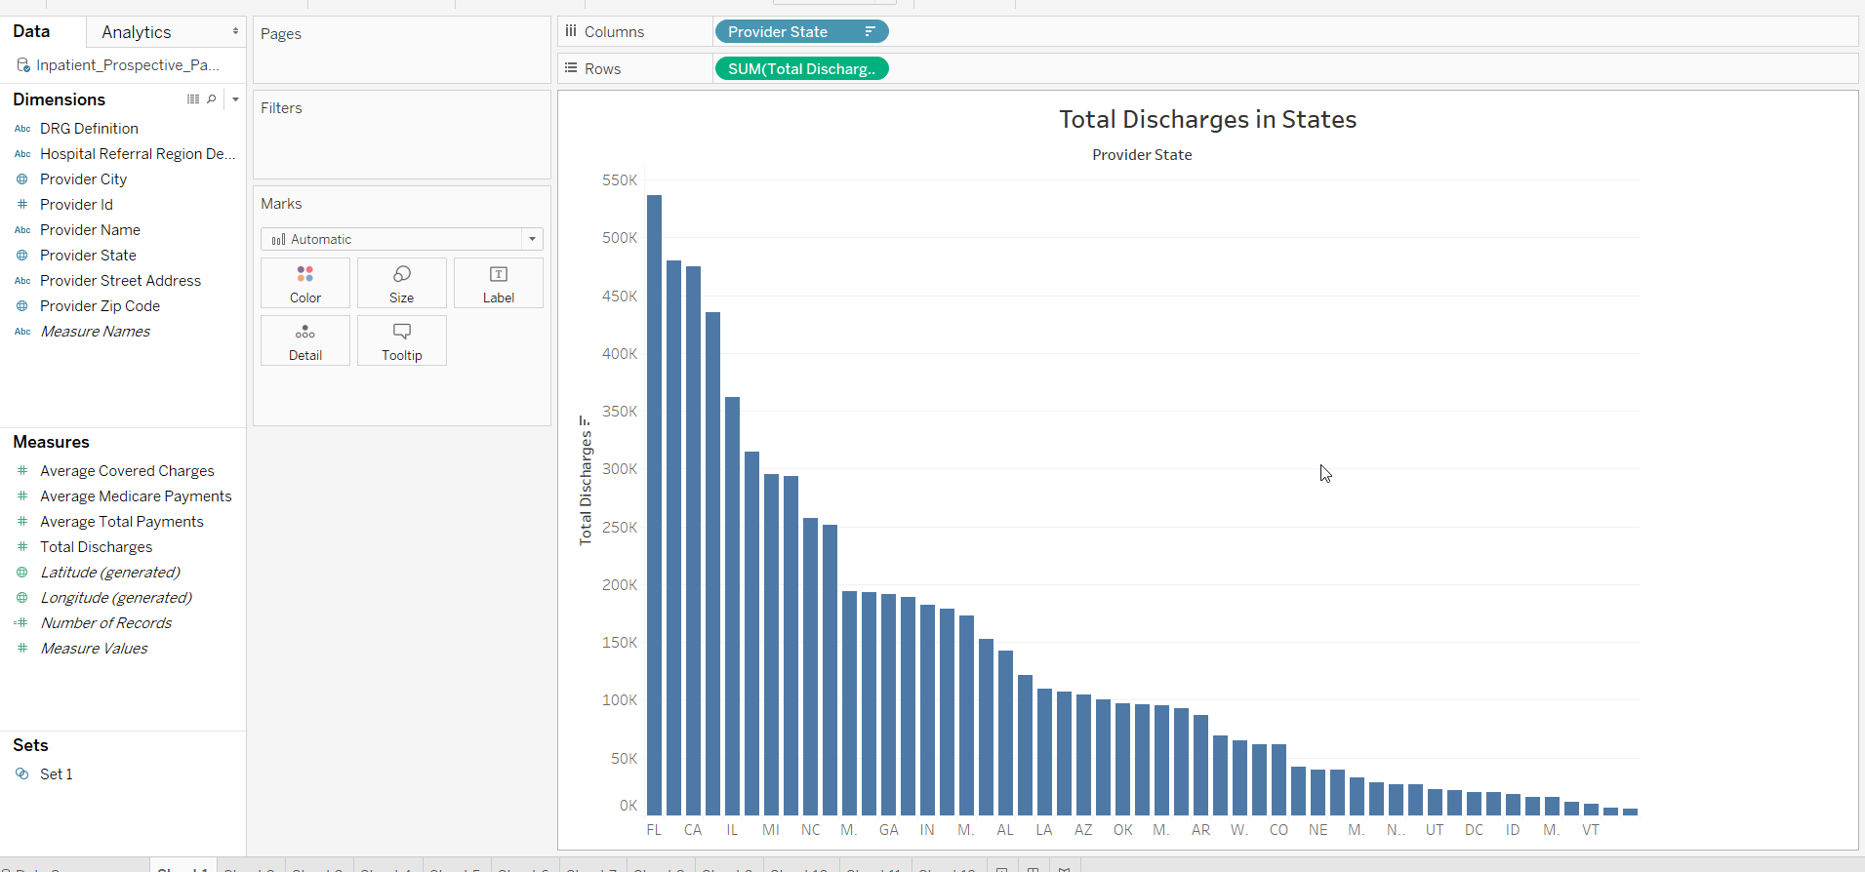

From the above plot it is evident that highest number of discharges are from FL, CA, IL, MI.